**Advanced Algorithms Prashanth.S (19MID0020)**

**1. Write a program to find whether a given string is present in the array of strings using**

**a. Linear Search Algorithm**

Code

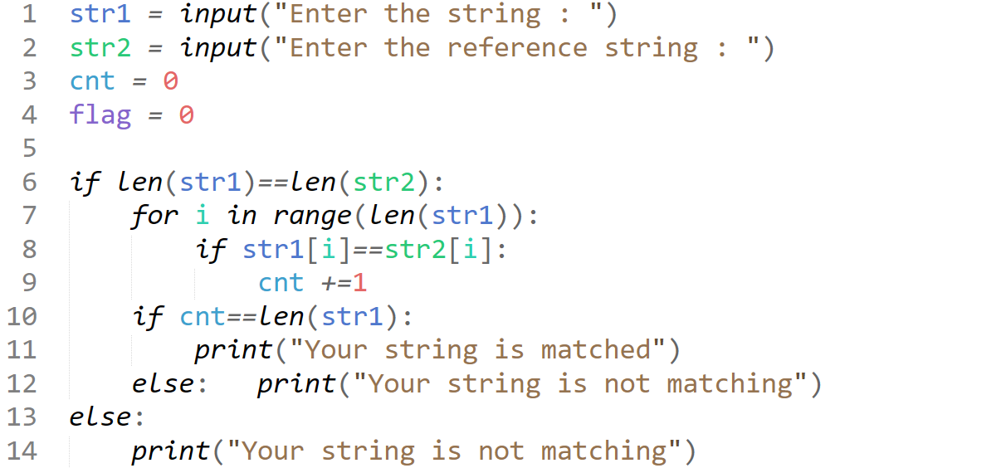

Output Case-1

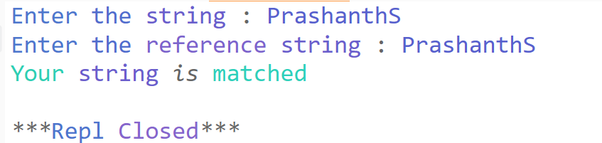

Output Case-2  
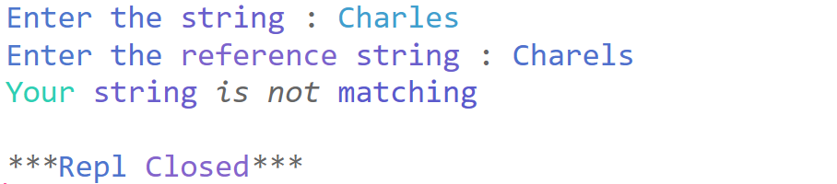

**b. Binary Search Algorithm**

**Code**

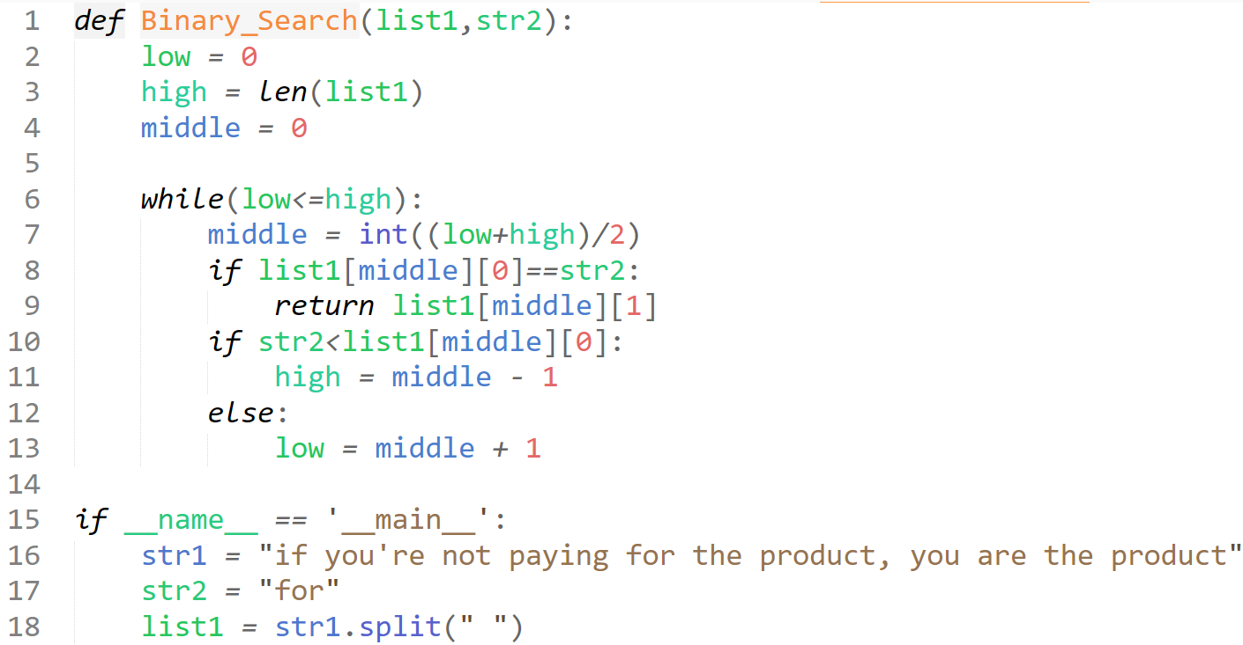  


**Output:**

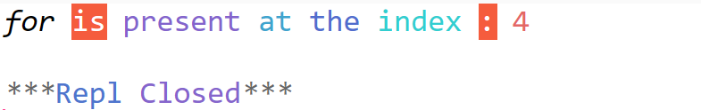

**2. Write a program to find the shortest path in a graph using Floyd-Warshall algorithm.**

**Code:**

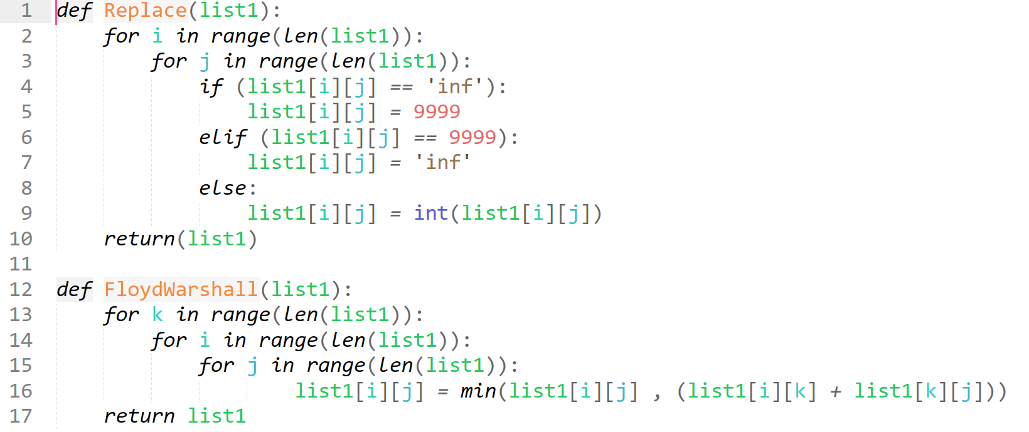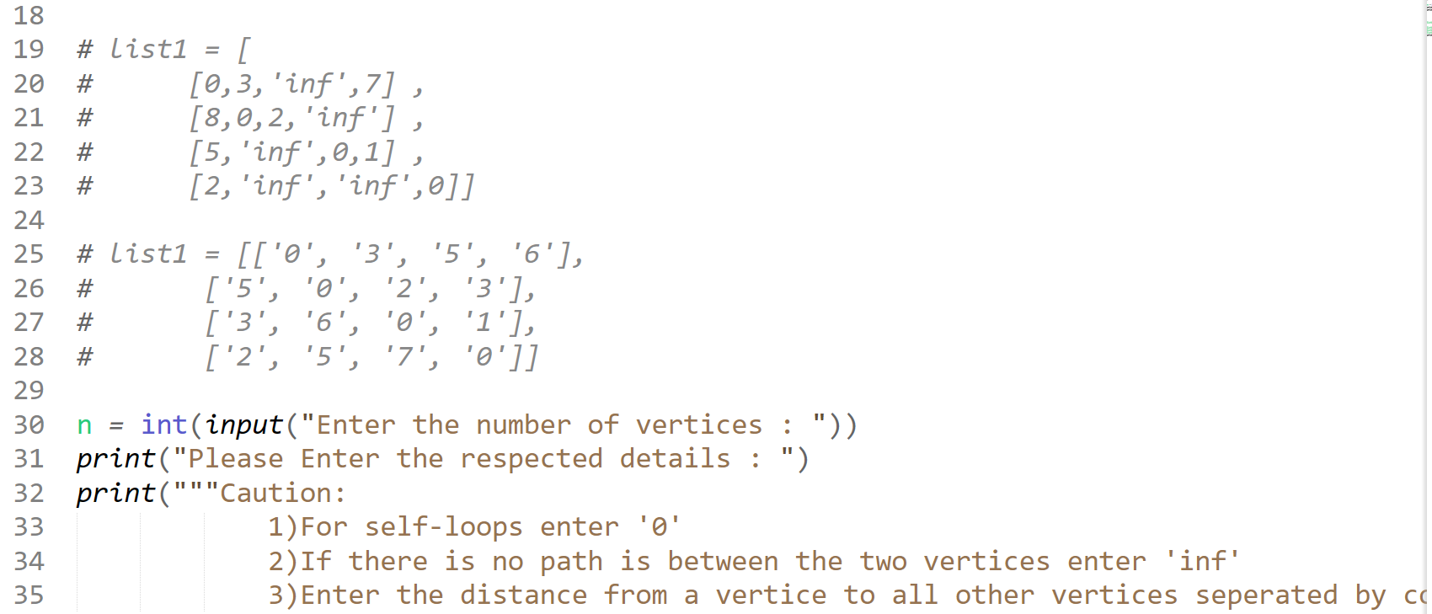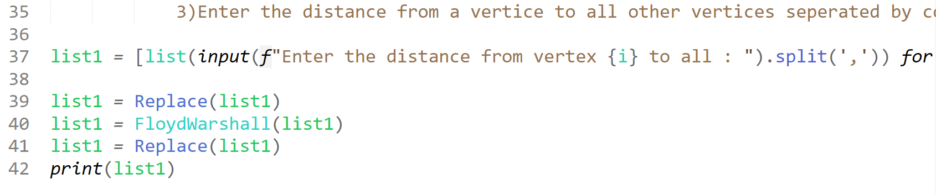**Output:**

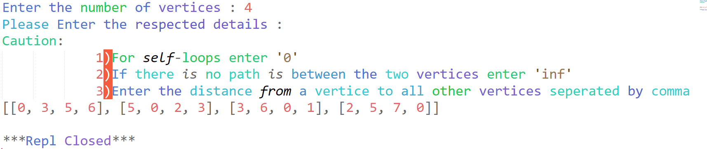

**3. Write a program to implement the Ford-Fulkerson Method.   
Code**

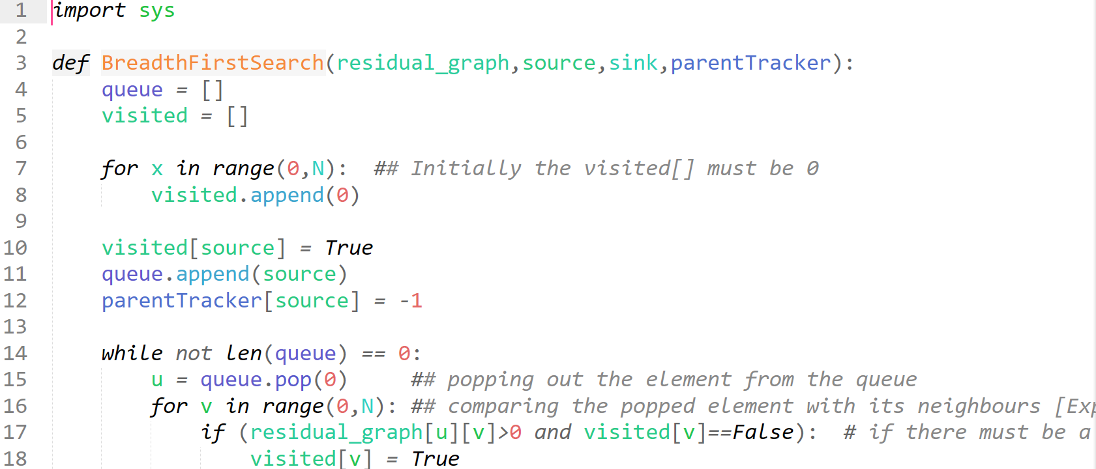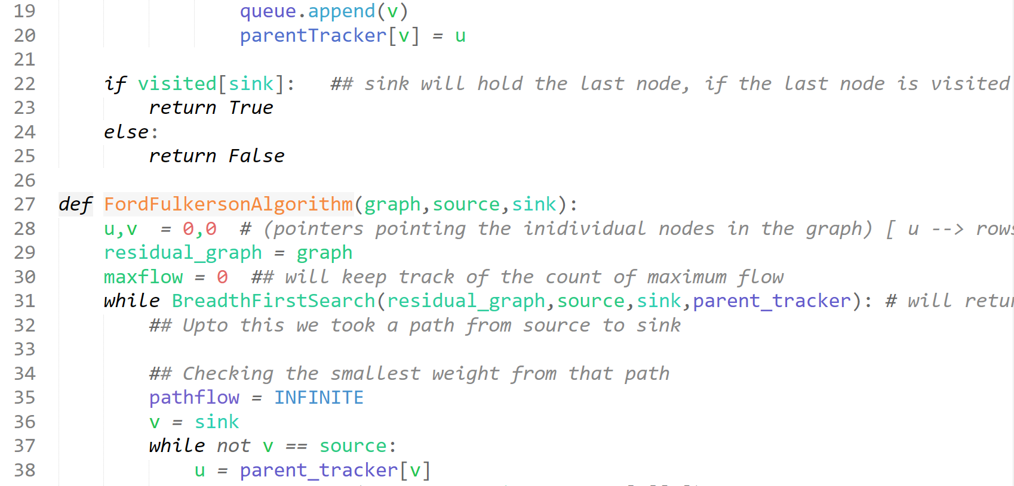

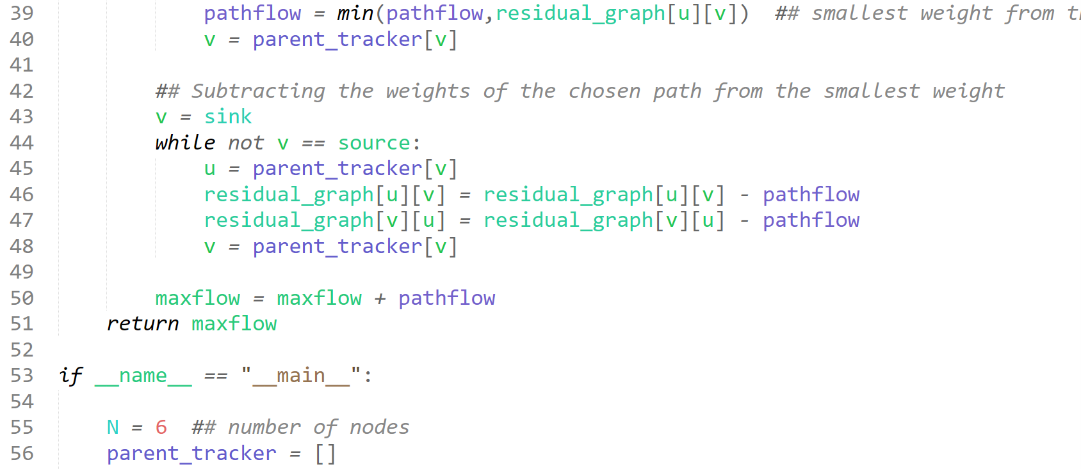

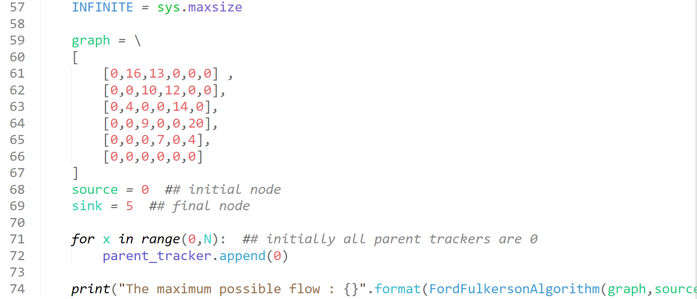

**Output:**

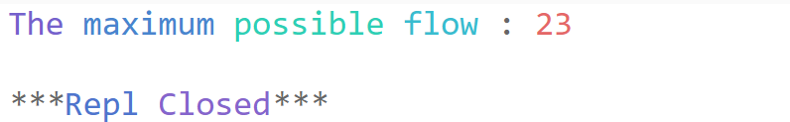

**4. Write programs to implement the following algorithms:**

**a. Fractional Knapsack Problem**

**Code**

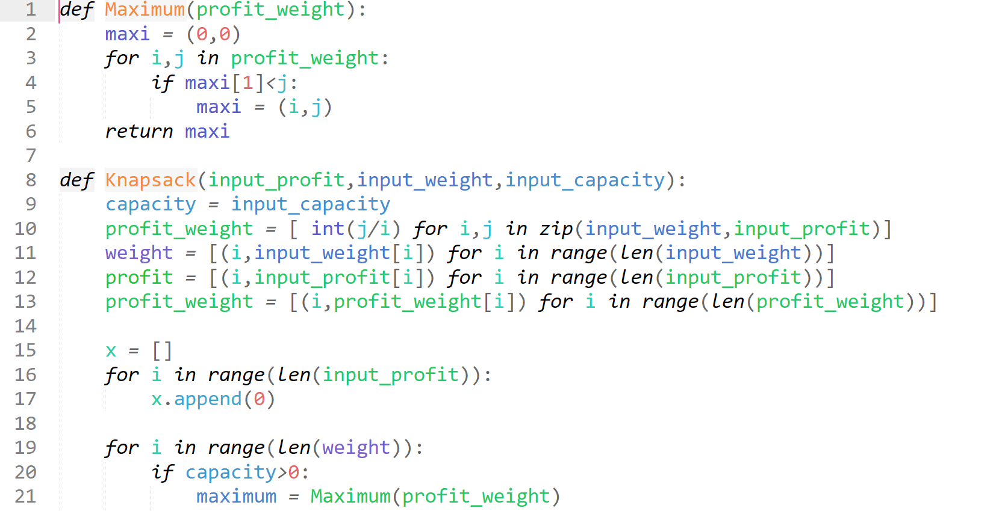

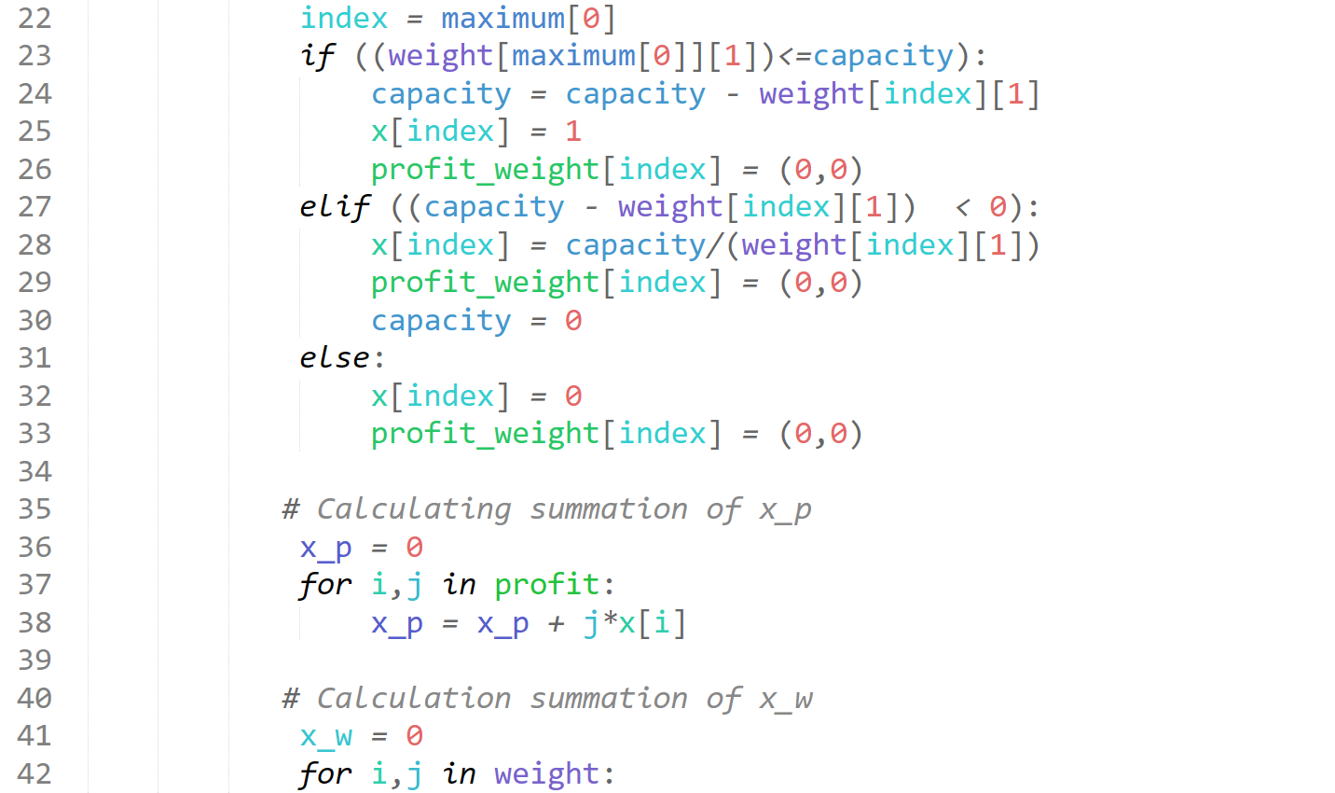

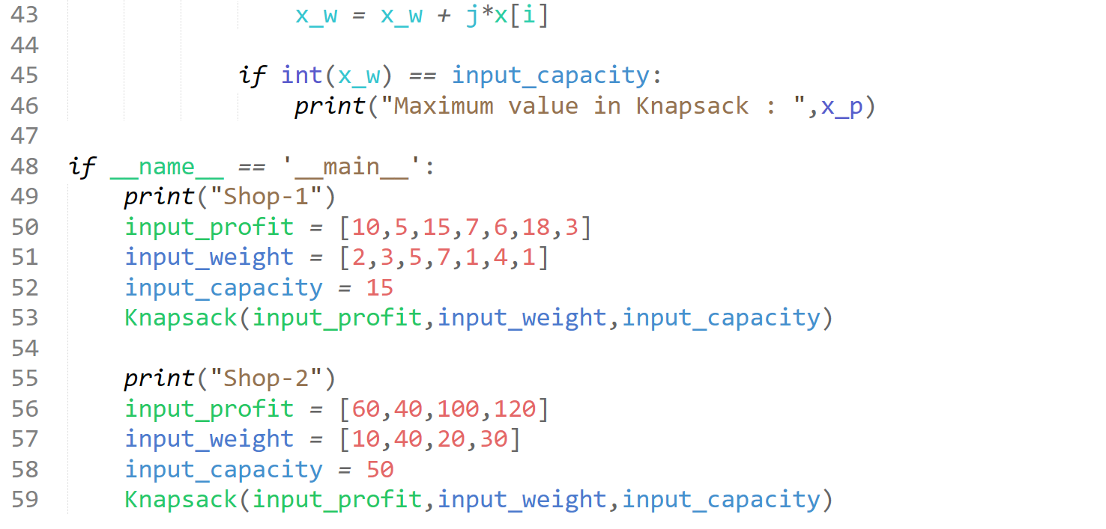

**Result**

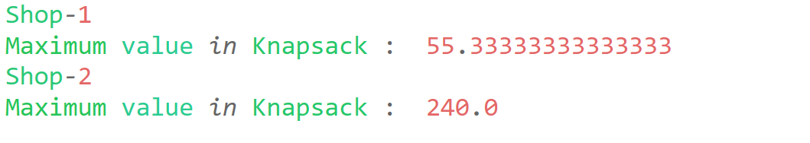

**b. 0/1 Knapsack Problem**

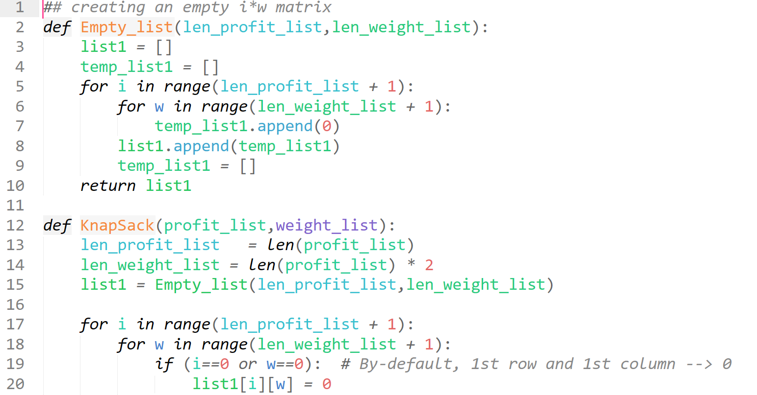

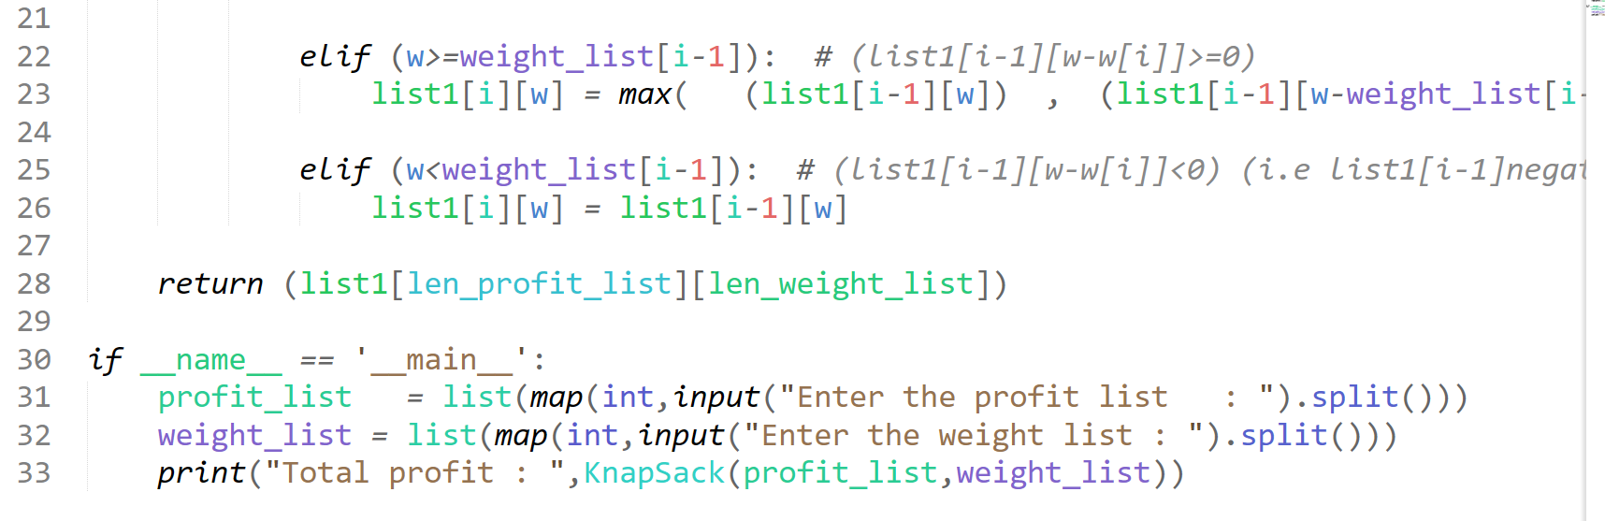

**Result**

